Lab 2 Report

6. (1)a

Formula, Truth Table and Description of the Circuit.

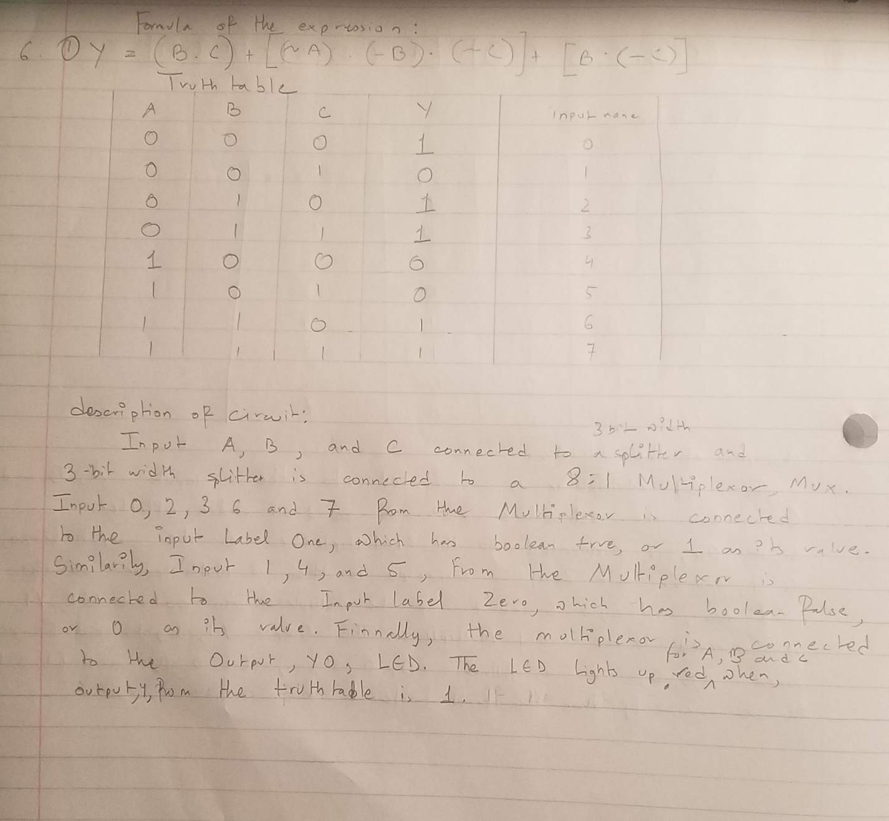

Circuit Diagram:

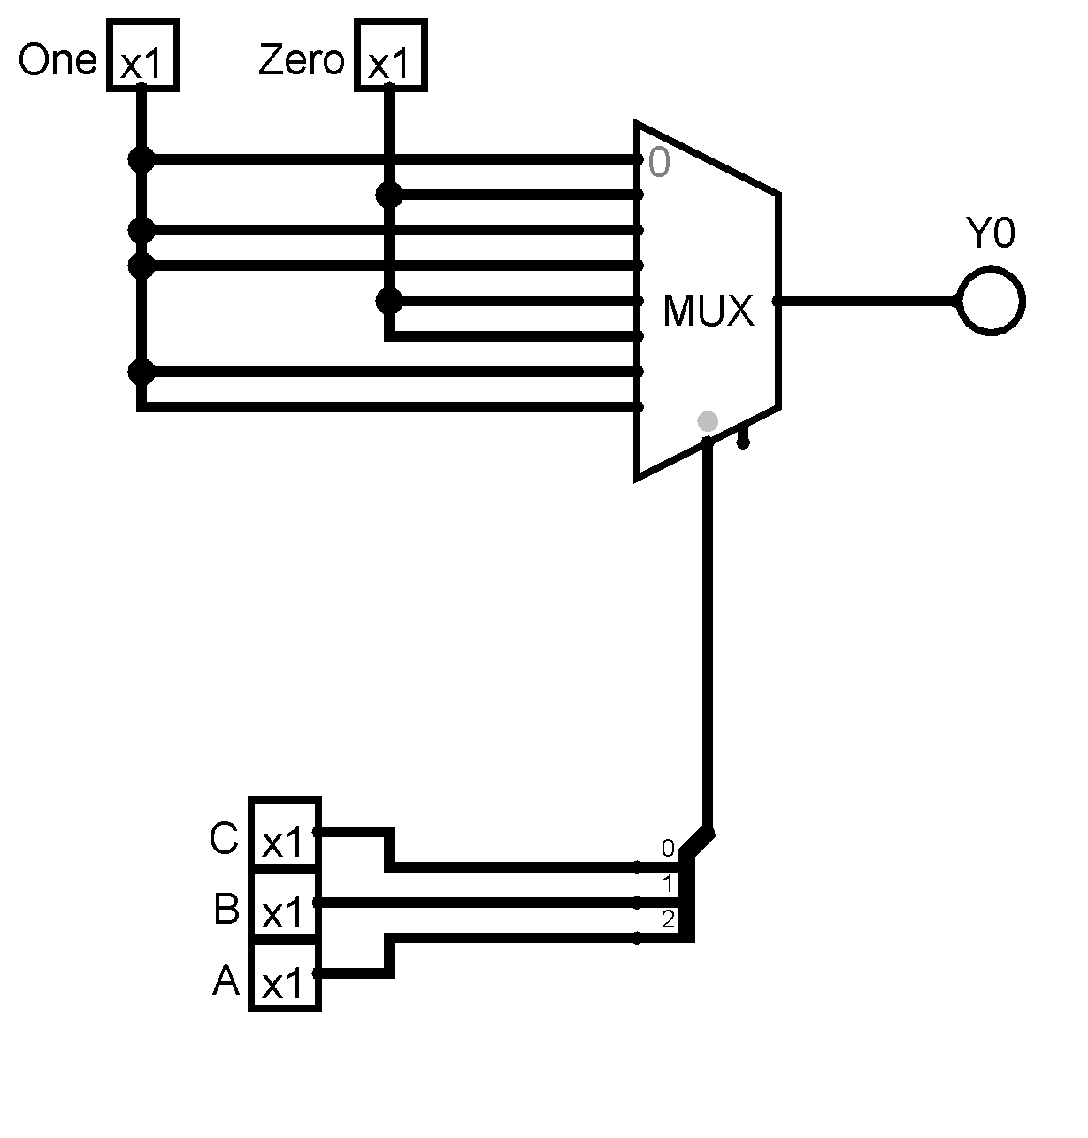

6. (1)b

Formula, Truth Table and Description:

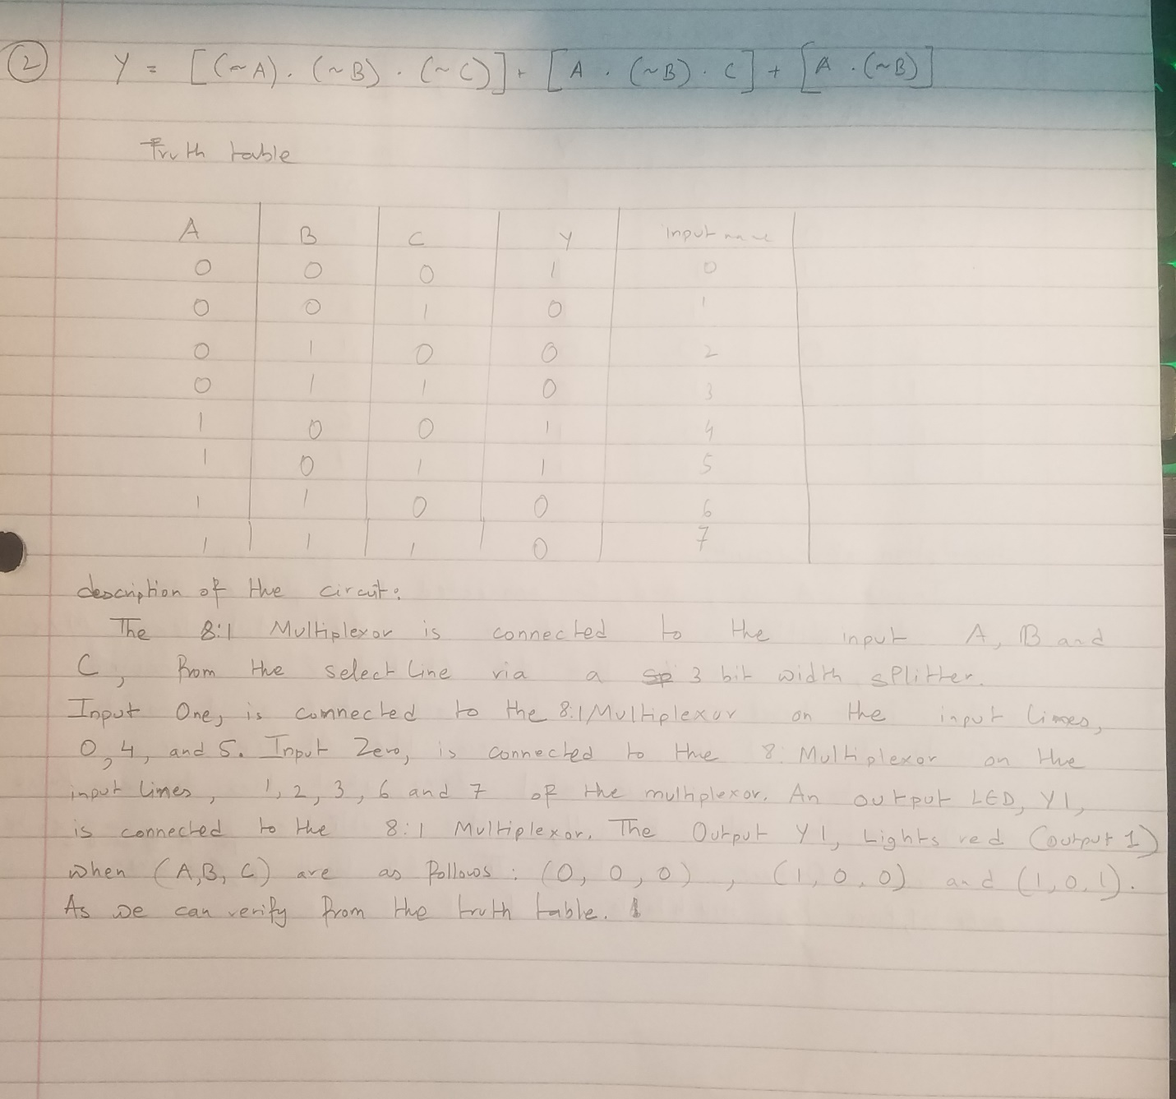

Circuit Diagram:

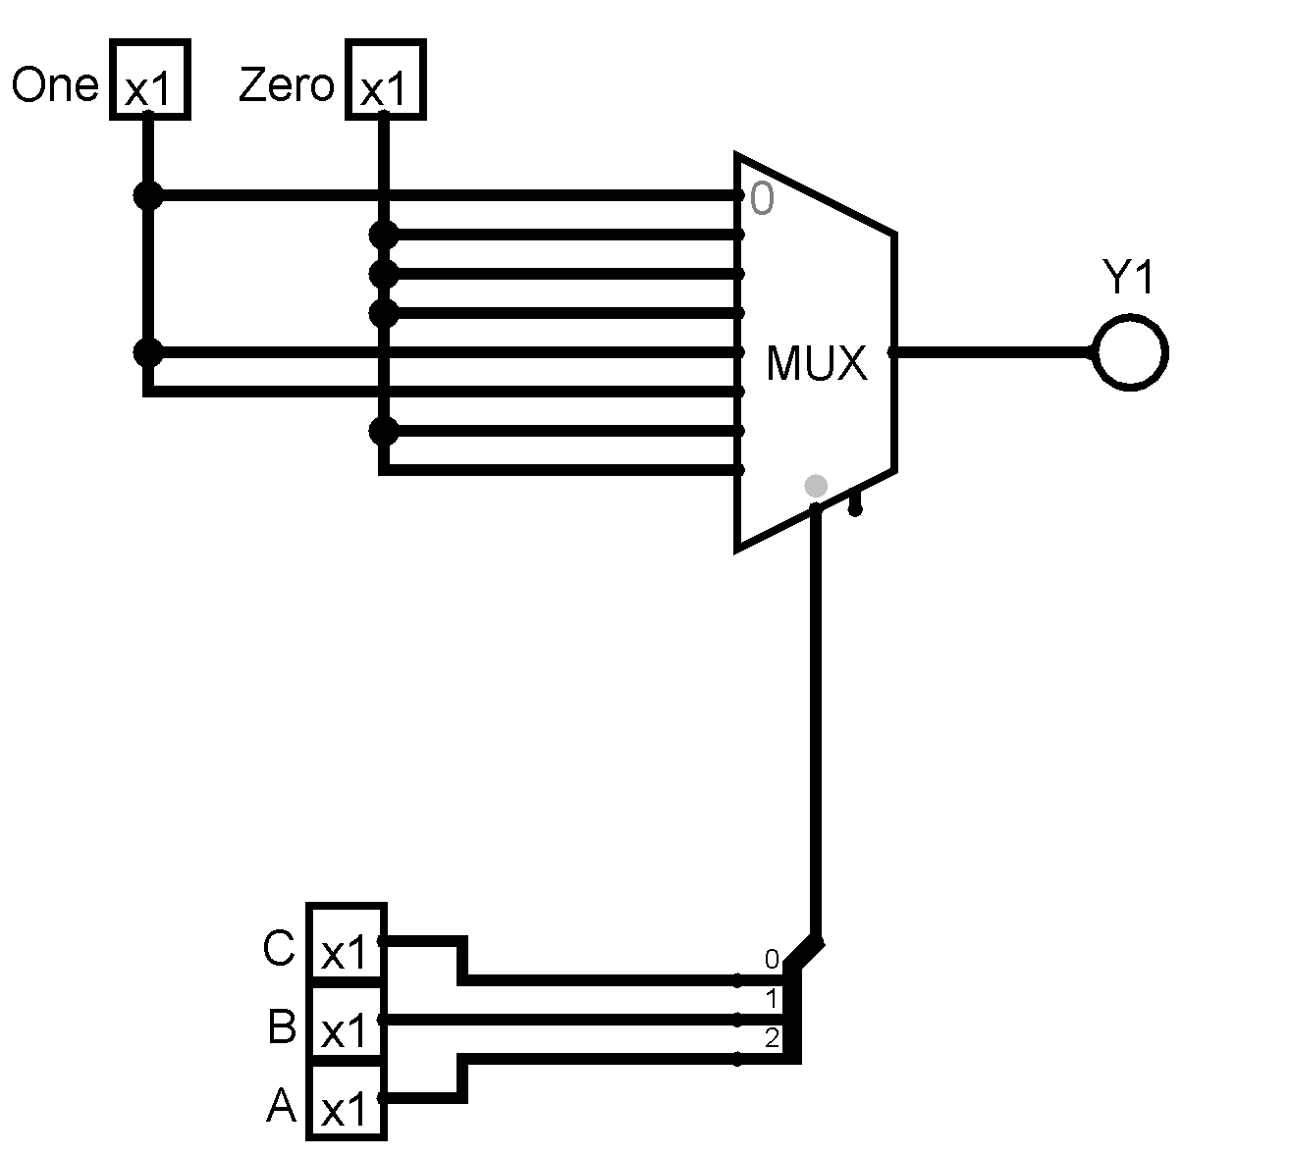

6. (2) FULL ADDER

Formula of the Expression:

SUM = (A XOR B) XOR Cin = (A ⊕ B) ⊕ Cin

COUT = A AND B OR Cin(A XOR B) = A.B + Cin(A ⊕ B)

Truth Table:

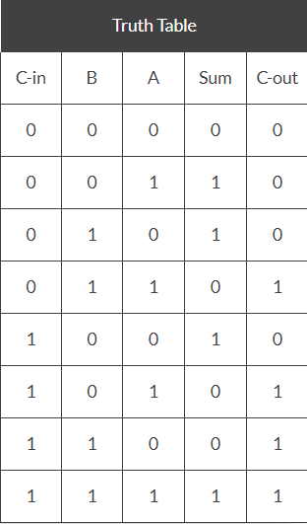

Circuit Diagram:

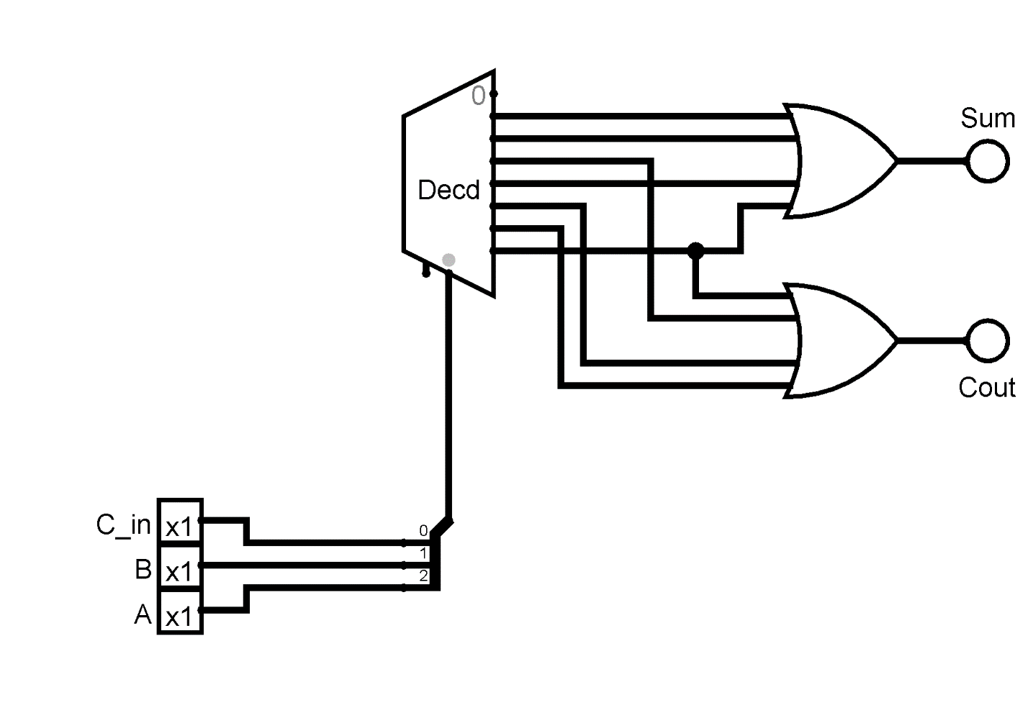

Description:

The Decoder has 3 select bits, The input C_in, A, and B are connected to the decoder. The output lines of the decoder are connected to, two Or Gates with 4 input pins. The output lines , 1, 2,4,and 7 are connected to a Or-gate, which is then connected to an Output LED, Sum. The output lines, 3, 5 ,6,and 7 are connected to a Or-gate, which is then connected to an Output LED, Cout. The Sum, LED lights up Red when the (C_in, A ,B ) are as follows: ( 0 0 1) , (0 1 0) , (1 0 0 ) and (1,1,1) if C_in, A and B are assigned respectively. The Cout, LED lights up Red when the (0 1 1), (1 0 1), (1 1 0), and (1 1 1) if C_in, A and B are assigned, respectively.

All circuit Diagrams:

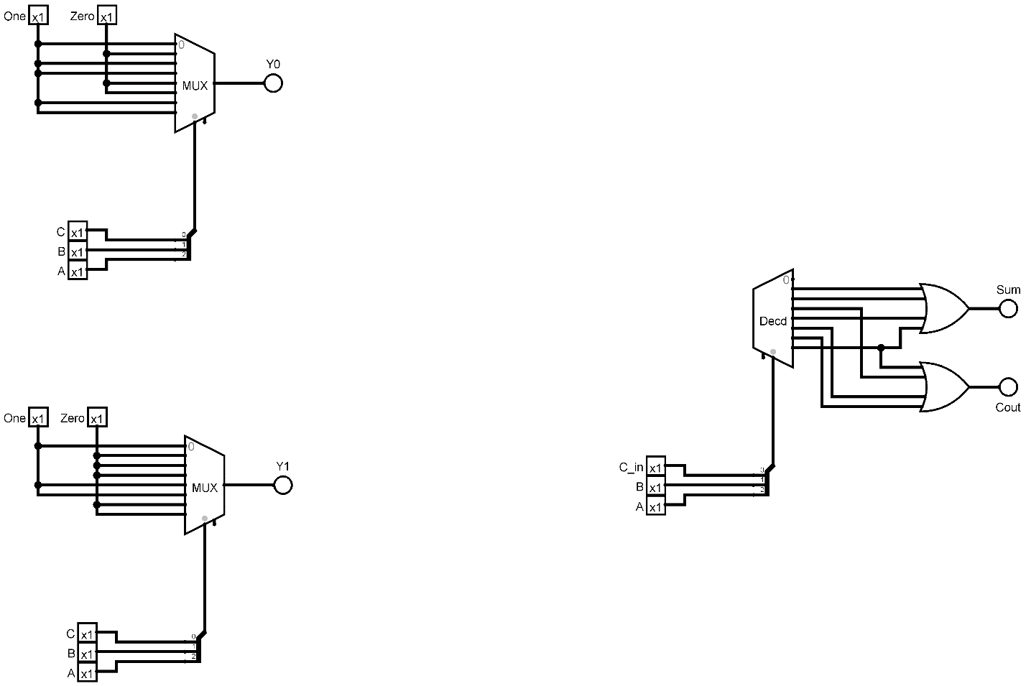

# Discuss your experience in the laboratory and any problems with the procedure.

# As the theory and definitions of the Multiplexors and Decoders were taught already in the class, I had no problems with the online laboratory, the procedure was simple and easy to understand.

* **Discuss any insights gained from the exercises.**

The usage of the splitters were new to me, so as using Multiplexor and Decoders. While doing the lab for Multiplexors and decoders, I could verify the logics with the help of the output LED.